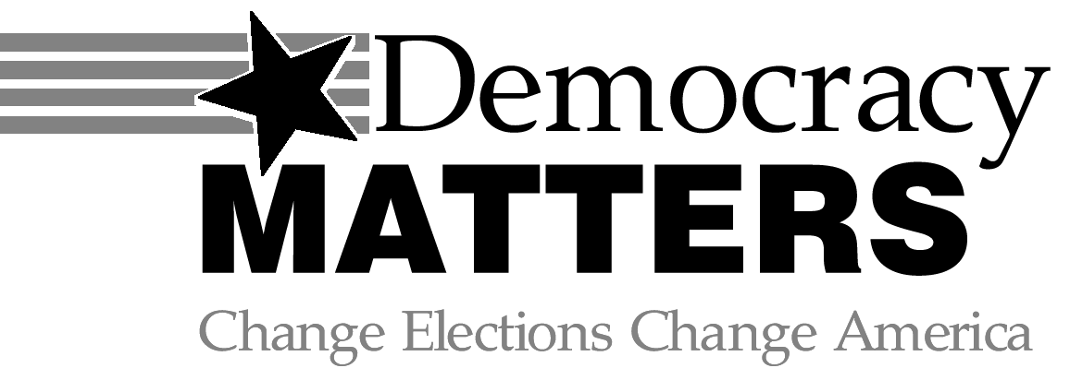

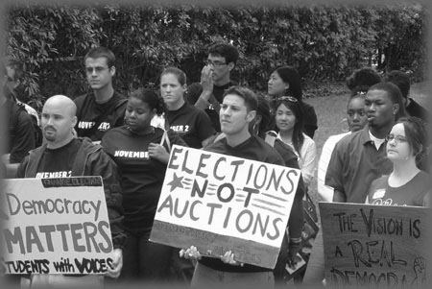

Registering to Vote Is Just the Beginning

Join Democracy Matters
at

(your school name)

- Organize to get big money out of politics and put the voices of the people back in.

- Impact change on all the issues you care about.

- Be part of the fastest growing youth movement in the country.

Environment · Health Care · Education Foreign Policy · Civil Rights · Poverty Economy · Media · Labor · Corruption

Contact Information:

Meeting Time/Location:

www.democracymatters.org
Vocalize
Organize
Train
Educate

