Civil Rights Women’s Rights
Justice for ALL

UNITE FOR CHANGE !

Students
for REAL
Democracy

If you care about the environ-ment, education costs, globalization, and civil rights, then you should care about the dominance of big money in politics.

Only when our government is responsive to voters— not just big donors — can we achieve true democracy where everyone’s voice is heard.

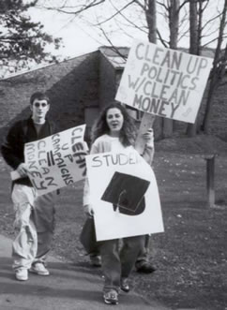

Clean Up
the
Environment!!!

Help get money out of politics —and people back in.

Join Democracy Matters, the fastest growing student movement in the country!

• Campus actions
• Student / faculty projects
• Regional and national conferences
• Grassroots organizing

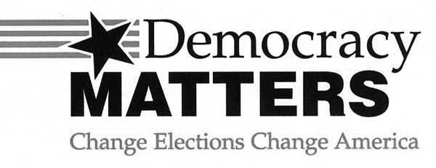

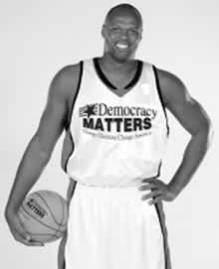

Meet Adonal Foyle — NBA star, Colgate University graduate, and founder of Democracy Matters.

“People say our generation is apathetic. But I don’t think so. We need to make some noise to stop the big donors and special interests from controlling policies on education, war and peace, the environment and the things we care about.

That’s why I started Democracy Matters—so that students could have the resources, mentorship, and actions to make a real difference. Join me in the fight to change elections, and change America.”

Democracy Matters is strictly non-profit and non-partisan.
THE FACTS:

$ Politicians depend on large private contributions to run their campaigns. Therefore they are more responsive and accountable to their big funders than to the majority of Americans.

$ Ordinary citizens are locked out of the system because they cannot afford to run for office.

$ Too much time is spent by politicians raising money instead of raising issues and governing.

$ Many people have lost faith in the system and don’t even bother to vote because they think candidates are bought and sold.

$Politicians depend on large private contributions to run their campaigns. Therefore they are more responsive and accountable to their big funders than to the majority of Americans.

In 2002, big special interests — not ordinary citizens — contributed over 90% of total campaign contributions.

$ Ordinary citizens are locked out of the system because they cannot afford to run for office.

In 2002, the average incumbent enjoyed a 5-1 fundraising advantage over his/her opponent. It’s no wonder that 20% of all congressional races went unchallenged.

$ Too much time is spent by politicians raising money instead of raising issues and governing.

U.S. senators spend 1/3 - 1/2 of their working hours over
their 6-year term raising money for re-election.

$ Many people have lost faith in the system and don’t even bother to vote because they think candidates are bought and sold.

In the 2000 elections, less than 18% of college age people voted. These rates have steadily decreased from 50% in 1972.
www.democracymatters.org
HOW TO GET INVOLVED:

