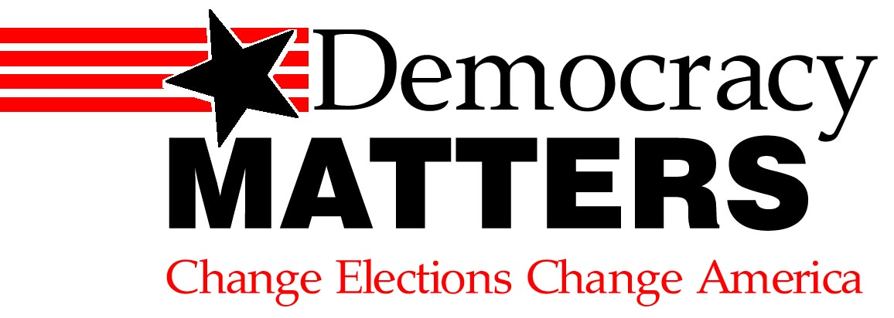

DEMOCRACY MATTERS is the fastest growing student activism group in the nation. Join us in the fight to get big money out of politics, and the PEOPLE back in.

IT’S TIME FOR A CHANGE.

Join UNION COLLEGE Democracy Matters and make your voice heard!

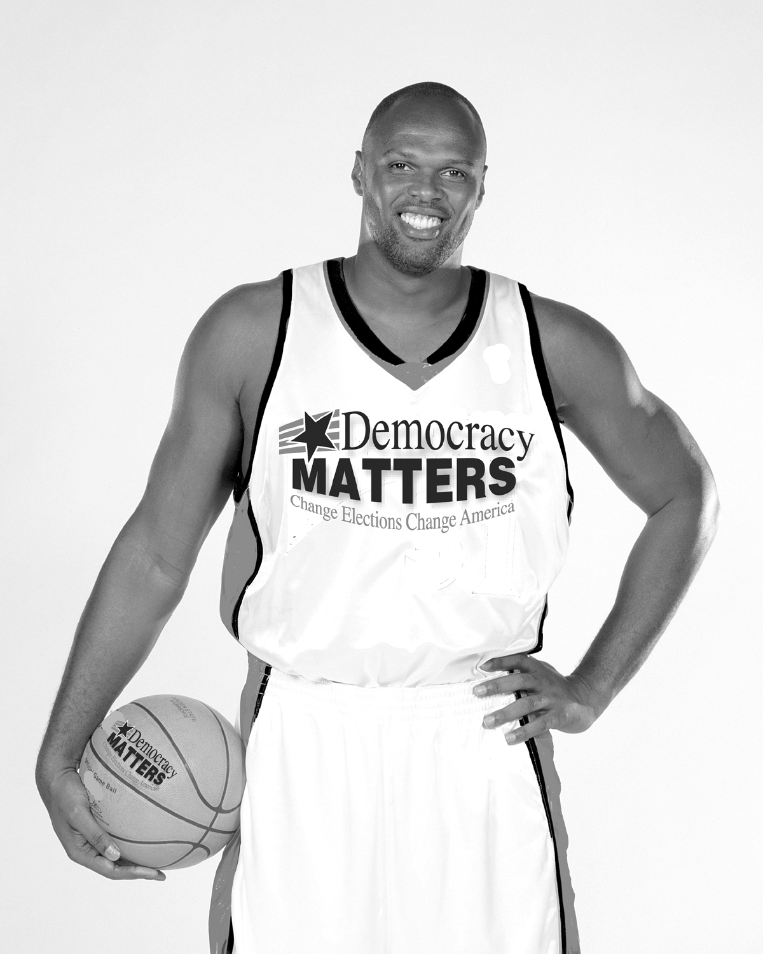

“I started Democracy Matters to help students fight for change by standing up to big money interests corrupting our democracy.” – Adonal Foyle, NBA Player, Founder and President

Contact Gabrilla Levine at levineg@garnet.union.edu

Or Dudley Okongo at okongod@garnet.union.edu

