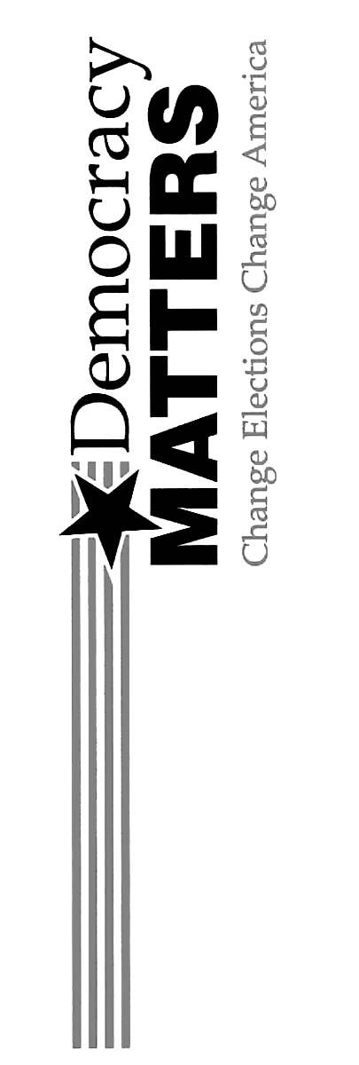

Unhappy with the current political system?

Interested in what we’re doing to change things?

Want to find out what you can do to help?

Come to a Democracy Matters meeting!

Thursday, 9/25
7 pm
Union 3202

Why should you come? Because…

DEMOCRACY MATTERS!
Your vote
or
their money

