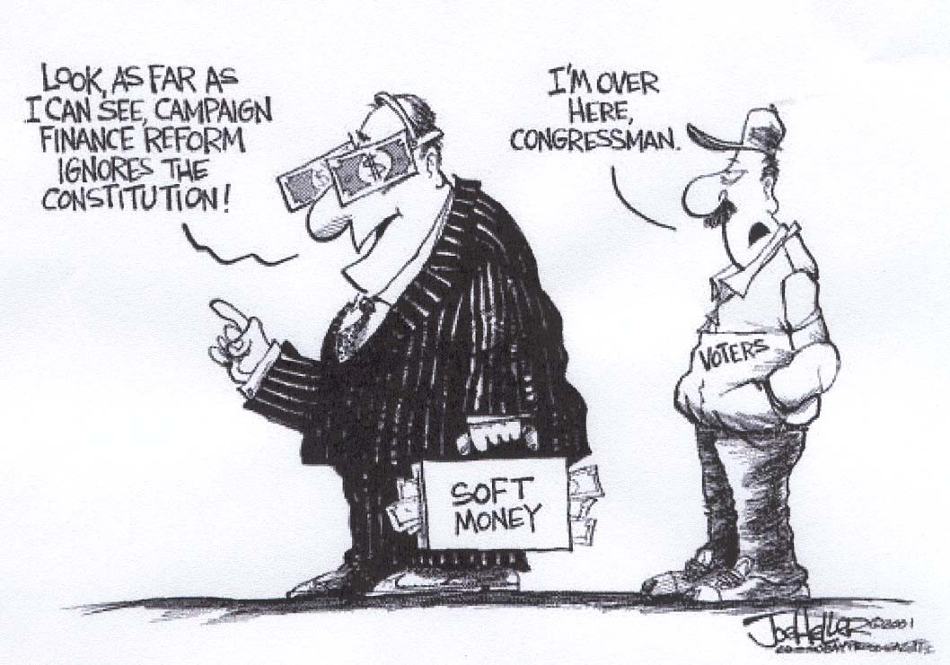

Open your eyes UR! Join

Democracy Matters

And do something about money in politics!

Interest meeting
7:00 pm Thursday, September 26
Wilson Commons, 5th Floor
Can’t make it? Email Erin ef002k

