Potty Politics
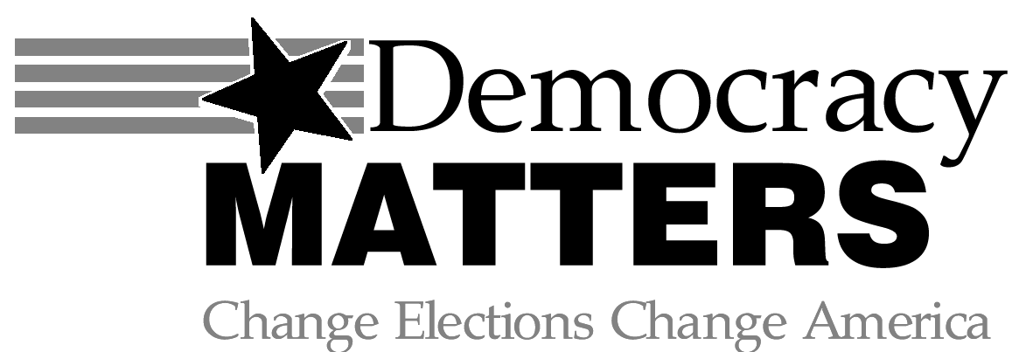
Vices APRIL 2011
FREE PIZZA AND POLITICS
THURSDAY, APRIL 14TH
6-8 PM SAINT PETER ROOM
RSVP at the table by Wednesday, April 13th or by emailing democracymatters@gustavus.edu

BRIEF BACKGROUND
Vice taxes are any taxes applied to goods or services considered “immoral.” Some examples include taxes on tobacco, alcohol, gambling, drugs, prostitution, and many others. Vice taxes are seen to be beneficial in two ways. First, they increase the cost of vices, decreasing their popularity. Secondly, taxes also increase revenue for the state. Controversies often arise because these taxes are biased against “vices” while also condoning “immorality.” It would be in the government’s best interest to increase the popularity of alcohol if they had a high tax rate on it. The facts included in the rest of this issue are meant to inform, but do not represent the entire complexity of these issues. For more information and discussion, attend our free Pizza and Politics event.
PROSTITUTION ^{2,3}
- In 1990, 23/100,000 Americans were prostitutes.
- In 2004, 15% of all men and 30% of single men over 30 had paid for sex.
- A proposed $5/session tax would generate $2 million/year for Nevada, where brothels are legal in several counties.
- Prostitutes are often targets for violence from pimps and clients.
- Children and foreigners are often forced into sex work by threats of violence and forced drug use.
- Drug addicts and homeless men and women often become sex workers.

MARIJUANA ¹
- 15 million Americans use marijuana at least monthly.
- The illegal marijuana industry is about $113 billion annually.
- State taxes on medical marijuana in Sacramento are about $800 million (~9%) annually. Applied nationally, that would be over $10 billion!
- 4/20 could replace 4/15 as tax day.
- The cost of the war on marijuana is $45 billion annually.
- The estimated annual cost of all illegal drug use in health care, crime and decreased productivity is estimated at $180 billion.

ALCOHOL ⁴
- In 2002, Americans spent $74.4 billion and drank 6.4 billion gallons of beer.
- Alcohol taxes are split into three categories: spirits, beer and table wine and tax rates are determined by the gallon.
- In Minnesota, the spirit tax is $5.03, table wine is $0.30 and beer is $0.15. Alcohol taxes vary by state and spirit taxes can range from less than $1 to over $10 while wine and beer taxes are generally lower.

DEMOCRACY MATTERS MEETINGS
WEDNESDAYS
6:30 PM
THE GUSTIE DEN
Sources:
¹http://articles.moneycentral.msn.com/Investing/StockInvestingTrading/a-budget-cure-marijuana-taxes.aspx#pageTopAchor
²http://www.lvrj.com/news/41816712.html
³http://en.wikipedia.org/wiki/Prostitution_in_the_United_States
4http://www.taxfoundation.org/taxdata/show/245.html

