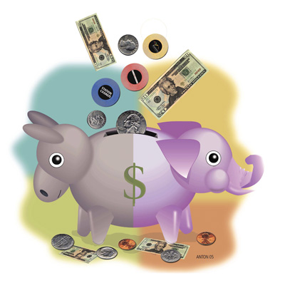
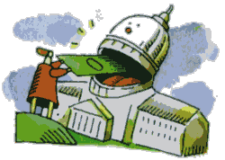


Money in Politics Quiz

1. What percentage of America donates $200 or more to a political campaign?

- 23%
- 0.25%
- 1.5%
- 10%

2. By the end of the 2008 presidential race, how much money will the two presidential nominees have raised and spent in their campaigns?

- 100 million
- 2 billion
- 500 million
- 25 million

3. How much money did each presidential candidate have to raise and spend in order to run a “competitive” 2008 presidential campaign?

- 10 million
- 100 million
- 500 thousand
- 1 million

4. On average, what percentage of time in office do most elected officials spend “dialing for dollars” and raising money for their next campaign?

- 10%
- 33%
- 75%
- 5%

5. On average, incumbents receive how much more money than their opponents?

- 2:1
- 3:1
- 4:1
- 5:1

6. How many Americans do not have health insurance?

- Forty five million
- Two hundred and fifty thousand
- One hundred million
- Twenty six million

7. On average, how much more money in campaign contributions did the Democrats who voted in favor of the War in Iraq receive from the oil and gas industry vs. Democrats who voted against the War in Iraq?

- 2:1
- 4:1
- 10:1
- 3:1

8. Who was the first sitting president to advocate for the full public financing of campaigns?

- Franklin D. Roosevelt
- George Washington
- Teddy Roosevelt
- Jimmy Carter

9. What percentage of Congressional races are won by the incumbent candidate?

- 17%
- 35%
- 60%
- 97%

10. In 1996, what was the first state to enact Clean Election Laws?

- Maine
- Arizona
- Vermont
- North Carolina

11. What Senator introduced the Fair Elections Now Act in March, 2007?

- Dick Durbin
- John McCain
- Jim Webb
- Barack Obama

12. Between 1996 and 2002 by how much did big business outspend labor unions in campaign contributions?

- 2:1
- 5:1
- 10:1
- 12:1

13. What percentage of campaign contributions come from non-Hispanic, White zip codes?

- 30%
- 50%
- 75%
- 90%

14. In the 2000 presidential election, what percentage of campaign contributions came from “small donors”?

- 30%
- 80%
- 19%
- 65%

15. How many lobbyists are there for every member of congress?

- 10
- 20
- 42
- 61

16. The amount of money needed to run a competitive congressional race has risen by how much since 1976?

- 2x
- 3x
- 4x
- 5x

17. How much did Money magazine estimate each household pays each year for legislation benefiting corporations and the wealthy?

- $500
- $50
- $1600
- $1000

18. What was the number one issue that was on the minds of voters during the 2006 mid-term elections?

- War in Iraq
- Health Care
- Corruption
- Education

19. How disturbed are you by the role money plays in politics?

- not at all
- somewhat
- very
- extremely

20. What are you going to do about it?

- Complain a lot
- Nothing
- Stop voting
- Join Democracy Matters and make a difference!

Information from:

Sifry, Micah & Watzman, Nancy. Is That a Politician in Your Pocket: Washington on $2 Million a Day. John Wiley and Sons; Hoboken, NJ: 2004

Answers:

1b, 2b, 3b, 4b, 5d, 6a, 7b, 8c, 9d, 10a, 11a, 12d, 13d, 14c, 15d, 16d, 17c, 18c, 19d, 20d

