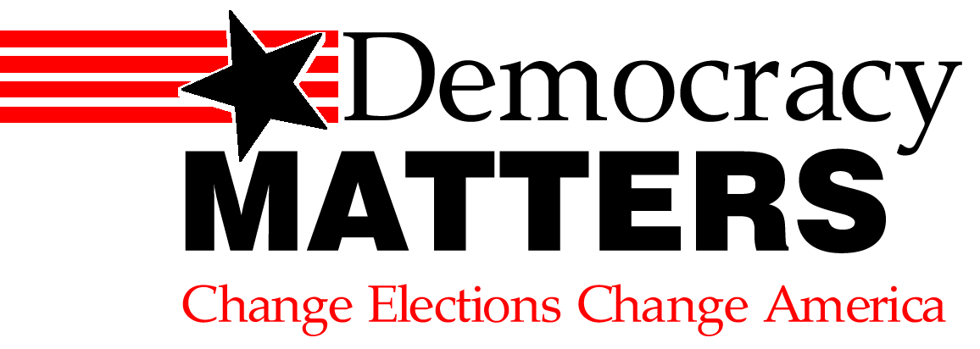

Lobbying Is Not Just For Big Business!

Scheduling the Meeting – Be Confident
- Congressmen and their staff members regularly meet with constituent groups in both their DC offices and their district offices, so call them up and schedule a meeting!
- When calling a district office, ask to speak with the staffer who handles your particular issue area. Then explain who you are, what bill or issues you want to talk about, and that you would like to meet with your representative on the subject. Or talk with the scheduler to set up an appointment.
- Know that meeting with a staff member can be as effective (if not more so) than meeting with the elected official. Staff members who agree with your position can become great advocates from within the office and also future good contacts.

Preparing for the Meeting –Know Your Stuff
- Bring outlines, support letters, newspaper articles and any other informational materials.
- Brainstorm and outline your introductions, a summary of the bill or proposal, and your main reasons for support.
- Brainstorm and list the questions you are likely to get and how you will answer them.
- Research and bring information about groups, constituents or congress members who have taken a position on the bill.
- Meet with and brief students who will be attending the meeting on proper conduct, and who will be responsible for saying what.
- Before the Meeting ask yourself:
What problem are we trying to address?
Why is this the right solution to that problem?
Who supports and who is against this proposal? What are the opposition’s key arguments?
What are my answers to the opposition’s arguments?
What do I want the official to do?
Why does this matter to constituents and students?

Conducting the Meeting – Be Respectful and Informative
- Dress appropriately in business formal attire.
- Be quiet, patient and polite while waiting for your meeting.
- Introduce your self and your organization. Be clear about your relationship to the district and other students on campus.
- Begin with a clear outline of why you have come and what you are seeking (support for a bill, help with an issue etc.). Present the issue objectively and concisely without wading into unnecessary details – save that information for questions.
- Don’t be argumentative, back the official into a corner, or wander from the issue at hand. They may need time to look over the legislation or request.
- Be a good listener and pay close attention to what the official says. Make notes of their views and the questions they ask.
- Never lie or make up answers to questions. It is always okay to answer “I don’t know” and offer to and get back to them with an answer. This is where good follow-up comes into play.
- Try to get a specific commitment – presenting materials to others, supporting a bill or talking to colleagues.

Follow-Up – Don’t Drop the Ball
- Take the official’s business card at the end of the meeting. Also give them your contact information.
- Follow-up with a letter (email may be appropriate for staff. Letters can be mailed or faxed) thanking them for meeting with you and reiterating your position and any commitments they made. If they did not commit, mention that you hope they will further consider the issue and your request.
- Include with your letter any new or additional supporting documents, and answers to any questions you were unable to answer in the meeting.

