MONEY IN POLITICS
MAY BE HAZARDOUS
TO YOUR DEMOCRACY !DdDEDEMOCHEALTH, ENVIRONMENT. ENVIRONM,E

Wealthy individuals and corporations donate billions of dollars to political campaigns to control our economic, environmental, educational and energy policies. Help us take back our democracy!

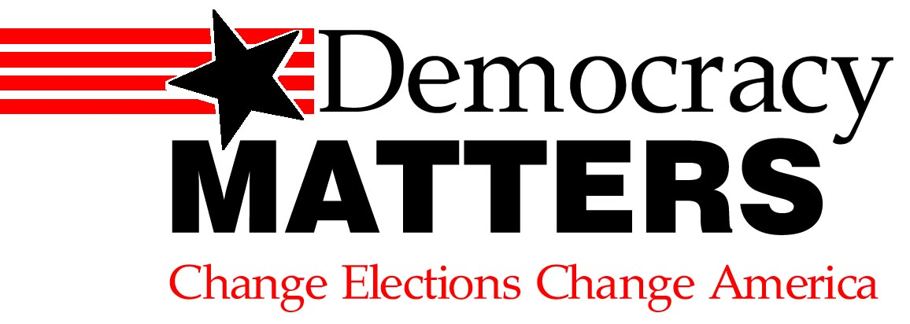

CONTACT (your school name) at
Learn more at our weekly meetings:
Wednesdays at 4:30 p.m. in Reeve 213
uwodemocracymatters@gmail.com

