MONEY IN POLITICS
MAY BE HAZARDOUS
TO YOUR HEALTH, ENVIRONMENT. ENVIRONM,E

Over the past decade, big pharmaceutical corporations, insurance companies, and HMOs have contributed over $997 million to national political campaigns, unfairly controlling health care legislation and debate.

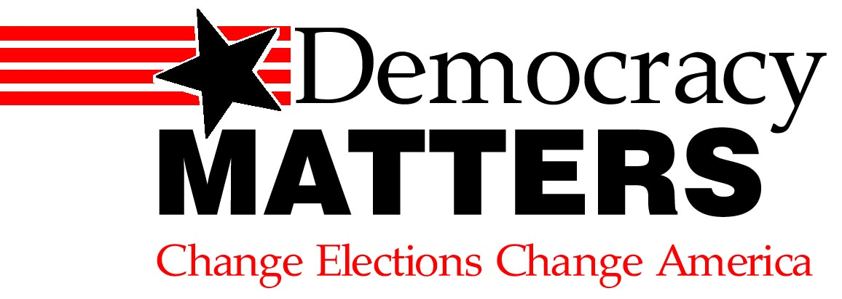

CONTACT (your school name) at
Learn more at our weekly meetings:
Wednesdays at 4:30 p.m. in Reeve 213
uwodemocracymatters@gmail.com

