MONEY IN POLITICS
IS HAZARDOUS TO
OUR ENVIRONMENT

Over the past decade, big energy companies have contributed over $576 million to national political campaigns, unfairly controlling our environmental policy and opposing renewable energy sources.

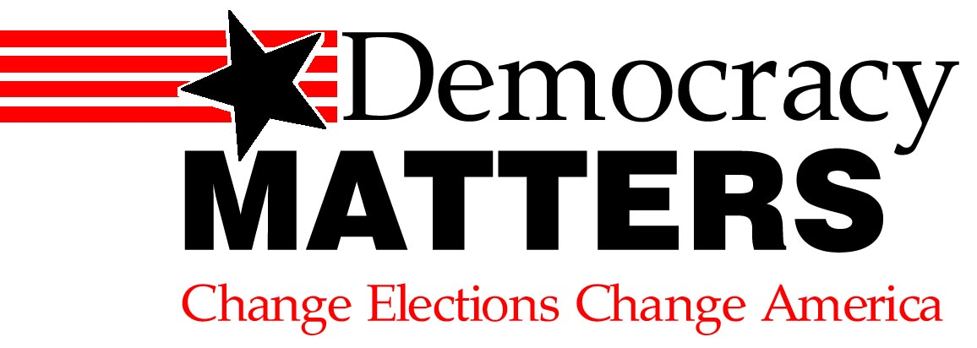

JOIN US: [Your contact info]
Learn more at our weekly meetings:
Wednesdays at 4:30 p.m. in Reeve 213
uwodemocracymatters@gmail.com

