EVERYBODY’S DOING IT!

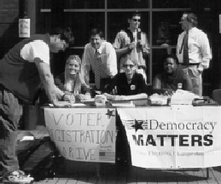

Students nationwide are working to achieve true democracy by getting money out of politics—and people back in.
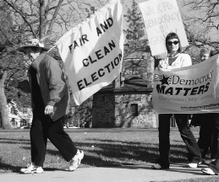
• Make a difference by getting involved in Democracy Matters—the fastest growing student movement in the country.

• Learn more about our campus chapters, actions, student/faculty projects, conferences, summer programs, and more!
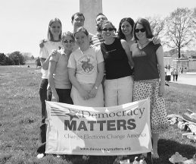

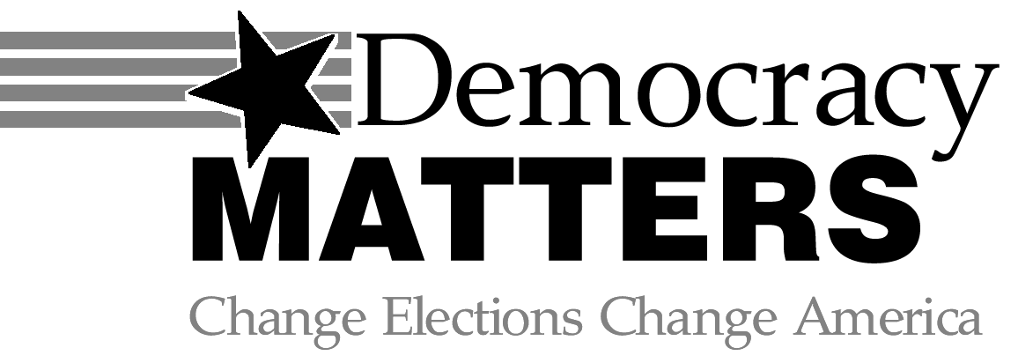

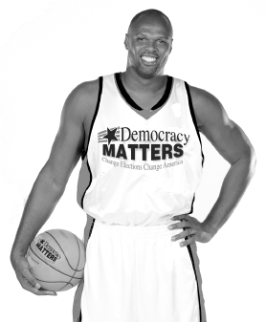

“I started Democracy Matters to help students fight for change by standing up to big money interests corrupting our democracy.”
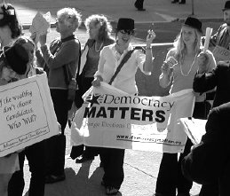

Adonal Foyle—
NBA Player, Founder and President,
Democracy Matters

CONTACT US TODAY  
THE FACTS:

“People say our generation is apathetic. But I don’t think so. We need to make some noise to stop the big donors and special interests from controlling policies on education, war and peace, the environment and the things we care about.”

Adonal Foyle, NBA Player, Founder and President of Democracy Matters

“.. [Public financing] is our generation’s civil rights movement... The beauty is this is not some far fetched unattainable pipe dream, but rather a movement with a defined and clear purpose...”

Nichole Diestel, Texas State Universtiy

“No matter what issue you are passionate about—education, women’s rights, health care, racial equality, social justice—reform starts with campaign finance reform...”
Amanda Ruthven, Mount Holyoke

“...Clean Elections would prevent ‘kick-back’ legislation, which provides millions of taxpayer dollars to private interests... It’s time to start plugging the holes in our democracy...”

Jake Miller, Bloomsburg University

$

Politicians depend on large private contributions to run their campaigns.
Therefore they are more accountable to their big funders and special interests than to the majority of Americans.
$

Student voices are ignored on important issues ranging from tuition increases to environmental protection.
$

Ordinary citizens are locked out of an unfair system because they cannot afford to run for office.
$

Too much time is spent by politicians raising money instead of raising issues and talking with voters.
$

Many people have lost faith in the system and don’t even bother to vote because they think candidates are bought and sold.
HOW TO GET INVOLVED:

www.democracymatters.org
Democracy Matters is strictly non-profit and non-partisan.

