
The Most Crucial Part In Being Elected Is Not Being the Best

…It’s Being the Wealthiest

Did You Know that Politicians Spend More than 50% of Their Time Raising Campaign Funds?

We Will Change That With Your Help

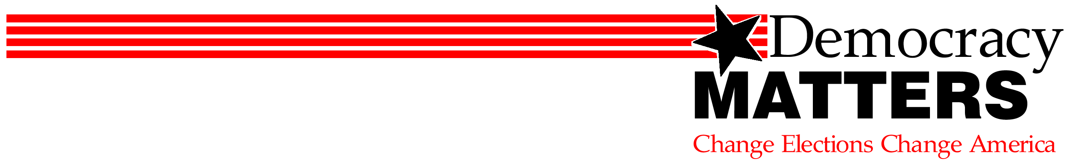

First Meeting Wednesday
January 28, 4p in 163 Centennial

www.democracymatters.org

