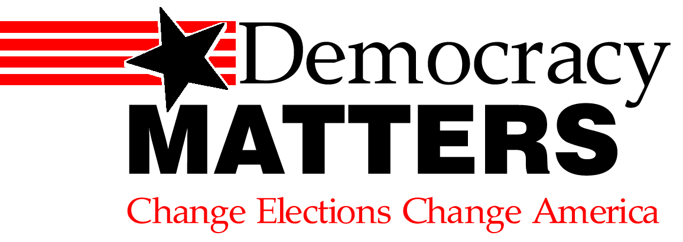

The Most Important Money Exchange Doesn’t Even Reside On Wall Street…

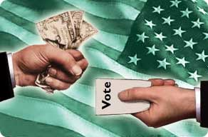
…It’s In Campaign Funding

Come See What We’re All About

1st Meeting Wed., Jan. 28, 4p in 163 Centennial

www.democracymatters.org
budemocracy@yahoo.com

