
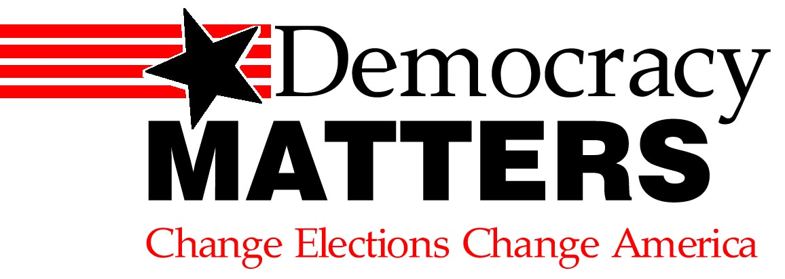
Anger-2-Action
If you care about the environment, education costs, globalization, and civil rights, then you should be angry about the dominance of big money in politics.
Thurs, April 28
6 pm Fein. 400
- Panel discussion with DM representatives
- Pizza and beverages
- Protest bracelets
- Meet and greet with DM
- Chance to be a part of a bigger movement for a better America
Introducing Democracy Matters, the fastest growing student activism group in the country. UNITE TOGETHER with Democracy Matters so we can finally get MONEY OUT of politics – and the PEOPLE BACK IN.
Sponsored by the Political Science Department and PC Democracts

