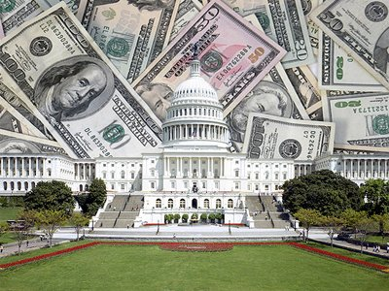

Democracy Matters
Tuesdays
SUB 409 @ 6pm
Democracy Matters
Tuesdays
SUB 409 @ 6pm
Democracy Matters
Tuesdays
SUB 409 @ 6pm
Democracy Matters
Tuesdays
SUB 409 @ 6pm
Democracy Matters
Tuesdays
SUB 409 @ 6pm
Democracy Matters
Tuesdays
SUB 409 @ 6pm
Democracy Matters
Tuesdays
SUB 409 @ 6pm
Democracy Matters
Tuesdays
SUB 409 @ 6pm
Democracy Matters
Tuesdays
SUB 409 @ 6pm
Democracy Matters
Tuesdays
SUB 409 @ 6pm
If you care about the environment, education costs, globalization, and civil rights, then you should be angry about the dominance of big money in politics.

General Interest Meeting

