Bubble Bubble Big
Oil and Trouble
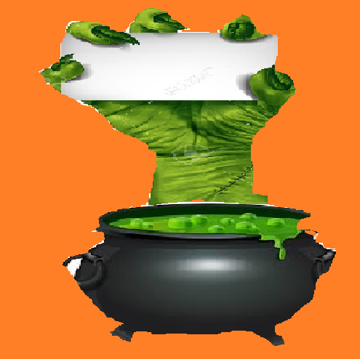
The 2016 election and what it means for our environment
Sponsored by Democracy Matters, PSIR, NYSR, NYPIRG, and SusAg

