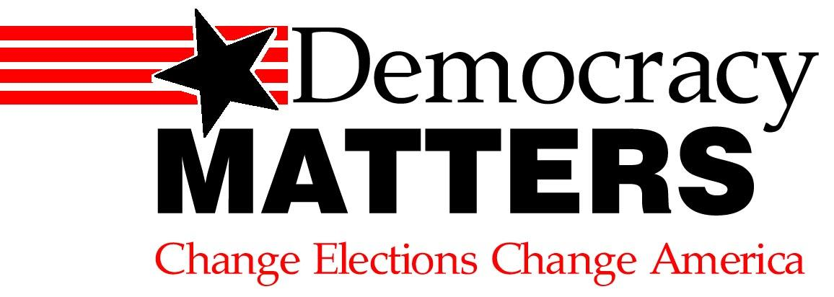

**Does your vote really matter?**

**Follow us on Facebook- DEMOCRACY MATTERS AT NEW PALTZ**

**Join us Mondays at 6:30pm in Library room M43**

We all know democracy is a process of citizen participation, with government accountable to the people. But today, it is not the people who have the power—it’s the donors. Those with the wherewithal to fund elections have eroded fair elections and accountability. Politicians have to answer to whoever gives them the most money; otherwise, they’re out of a job. Ultimately, votes don’t matter—its only how much you give.

**Here’s the Problem:**

Money equals victory. In **over 90%** of Congressional races, whoever **spends the most wins**. To advertise, pay staff, travel, rent offices, etc., politicians must raise money if they want to keep their job. **Elected** **officials spend between 30% and 70% of their time fundraising** for their next campaign instead of focusing on legislation. They’re there to represent you, not the richest company! What’s worse is how much the money actually counts: In the 2012 House of Representatives elections, the **winners outspent the losers 6:1.** In the senate, this ratio was **11:1.** Whoever gives the most gets to choose the politicians you can vote for and who will win. Conflicts of interest arise when **politicians are required to take money** from the same industries and interests for which they must write laws and regulate. It’s a little shady, don’t you think?

**How It Affects You:**

**Want to see environmental policy changed?**

The oil industry is one of the largest donors to congressional campaigns. They can afford to spend to fight alternative energy and keep oil subsidies.

**Want to see the gadflies removed from congress?**

Those responsible for the shutdown have the **incumbent advantage**: they have the greater ability to raise money. That is why **reelection rates are at minimum 85%.** Wealthy conservatives such as the Koch brothers keep donating to their cause. If they get the money, they stay in power.

**Every other issue imaginable!**

This is the gateway reform. So long as money runs politics, change cannot happen.

WHO WE ARE: Democracy Matters is a **non-partisan** national student organization. We don’t support any party—just fairness. We’re here at SUNY New Paltz making a change. Our mission is to get big private money out of politics and people back in. Come find out more **Mondays @6:00pm in Library room M43!**

www.democracymatters.org

Oh, we almost forgot to mention: **Contributions over $200 come from only 0.27% of the population but constitute 2/3 of the money raised.**