Fight the BIG $ takeover of our elections!! Join us!

**Democracy Matters** @

YOUR SCHOOL NAME

**Weekly meetings:**

DAY, TIME, LOCATION

**Contact:**

YOUR NAME

YOUR EMAIL

*Democracy Matters is a non-partisan, student-powered network educating campuses across the country about the corruptive influence of money in politics and what we can do about it!*

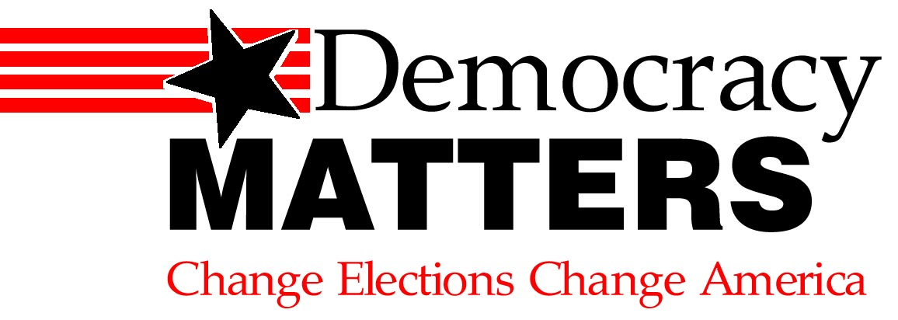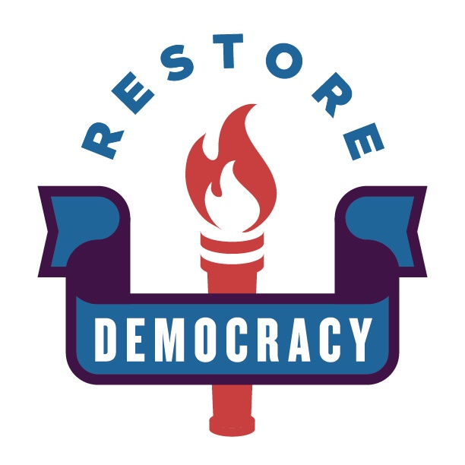

Fight the BIG $ takeover of our elections!! Join us!

**Democracy Matters** @

YOUR SCHOOL NAME

**Weekly meetings:**

DAY, TIME, LOCATION

**Contact:**

YOUR NAME

YOUR EMAIL

*Democracy Matters is a non-partisan, student-powered network educating campuses across the country about the corruptive influence of money in politics and what we can do about it!*



Fight the BIG $ takeover of our elections!! Join us!

**Democracy Matters** @

YOUR SCHOOL NAME

**Weekly meetings:**

DAY, TIME, LOCATION

**Contact:**

YOUR NAME

YOUR EMAIL

*Democracy Matters is a non-partisan, student-powered network educating campuses across the country about the corruptive influence of money in politics and what we can do about it!*



Fight the BIG $ takeover of our elections!! Join us!

**Democracy Matters** @

YOUR SCHOOL NAME

**Weekly meetings:**

DAY, TIME, LOCATION

**Contact:**

YOUR NAME

YOUR EMAIL

*Democracy Matters is a non-partisan, student-powered network educating campuses across the country about the corruptive influence of money in politics and what we can do about it!*

