**POTTY POLITICS – Democracy Matters @ Yourschoolnamehere**

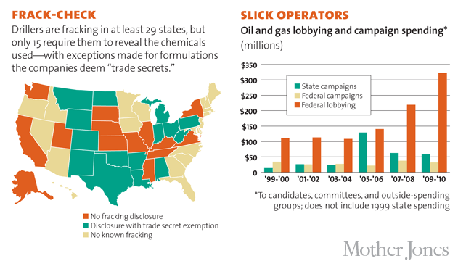

**Stop the billionaire money race!**

**Get big money out of politics and people back in!**

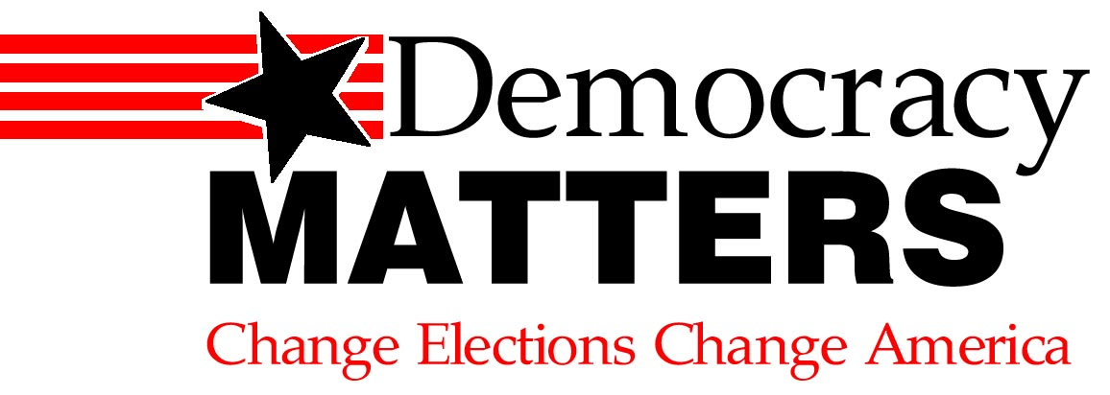



**Growing Environmental Concerns**

* The United States makes up roughly 5% of the world’s population, yet consumes 25% of the world’s fossil fuels.
* The United States remains oil dependent, neglecting to invest in or support research and development of renewable energy resources.
* The energy sector as a whole gives multiple millions to campaigns each year, dwarfing the contributions from environmentalists.
* Climate change deniers in Congress have blocked United States action to reduce climate change.

*Resist!!*

On April 22 and 29 there will be huge marches in DC and across the country - the Science March, Earth Day and the Climate March. Most students can't get to these marches, but we are bringing the ideas of the marches to our campuses in solidarity. We are speaking out against attacks on science, our environment and real “facts.”

“Outraged students are sick of the stranglehold that Big Oil and King Coal have on our energy system.” *(Sierra Club)*

*************

**Join Democracy Matters!!** @Yourschoolnamehere!

**Weekly meetings:** Time/Date

**Location:** Hall/RoomNumber

**Contact info:** Youremail@email.com